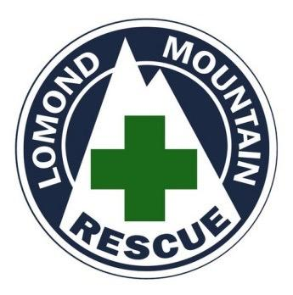

Probationary Membership Application Form

INTRODUCTION

Lomond Mountain Rescue Team accepts applications from individuals with the appropriate skills to apply for Probationary Membership.
We expect applicants, at the very least, to be very experienced hill walkers. Confident in both summer and full, winter conditions - with a good number of years’ mountaineering experience under their belts. Application forms should reflect this. Ask yourself, 'Am I happy in my own abilities, in poor weather, on steep terrain in the middle of a typical Scottish winter night.' If the answer is no, then you should probably reconsider.
Qualifications in relevant skills are looked on very favourably e.g. outdoor and medical awards etc. You must hold a valid first aid certificate before being accepted for full team membership.
Preference is given to applicants who are established within, or in near proximity, to our call out area in the Loch Lomond & Trossachs National Park. For practical reasons (cost and time spent training) we are looking for individuals who are settled in the region and demonstrate a long term commitment to Lomond MRT.
Each Autumn, the Committee reviews all application forms received, and invites suitable candidates to a selection day. The format is flexible but it will involve an introductory welcome at our Post, in Drymen, and then spending time on the hill with personnel and other prospective members. General hill craft, navigation and team work play a part in the selection process
If accepted, individuals will be invited to begin their probationary training year in January. During the year, individual performance as a group member, attendance and skill development are continually assessed.
For prospective trainees it is vital that the level of commitment to the Team is stressed at the outset and fully understood. The Team is a significant undertaking and it will eat into days that would normally be spent walking, climbing, or with your family. Over the period of an average year the Team meets for over forty different events (training, fund raising and safety cover) this does not include rescues. In practice, it means that most weeks will involve some kind of Team related event if awarded full team membership.
In the first year the Team expects 80% attendance from probationary members. During this time trainees are not part of the call out list and will not take part in rescues. At the end of this period, the Committee will consider your suitability and performance through the year.
If successful you will be invited to become a Full Team Member with Lomond Mountain Rescue Team.

PERSONAL INFORMATION

Name |  |  | DoB
Address |  |  | Occupation
 |  |  | Home Tel.
 |  |  | Work Tel.
 |  |  | e-mail
Postcode |  |  | Mobile

Describe briefly your current occupation and your availability to make regular training.

Describe briefly your mountain experience over the past 5 years.

Please state your reasons for seeking membership of the Lomond Mountain Rescue Team.

EXPERIENCE

In which of these activities are you involved? Please outline your experience in the following activities where applicable, including any grade where appropriate:

Summer hillwalking Activity | Years & Level
Winter Mountaineering Activity | Years & Level
Rock Climbing | Years & Level
Other Relevant Outdoor Activities | Years & Level

HEALTH & FITNESS
Yes/No

Are you fit enough to take part in a full day's mountaineering exercise?

CURRENT QUALIFICATIONS

Please list any current formal training/qualifications. Do you possess any of the following qualifications?
 | Yes/No | Date Achieved
First Aid Certificate (name it)
Summer Mountain Leader Award
Winter Mountain Leader Award
Mountain Instructor Award
Single Pitch Award
Other?

CONTRIBUTION TO THE TEAM

All members make particular contributions to the work of the team through training, leadership, administration, etc.. Describe briefly the role you would expect to play within the team as well as any special skills/experiences you would bring.

SPONSORSHIP

If possible, state the name of an authoritative person (e.g., existing team member) who is able to support your application.

DECLARATION

I hereby declare that the information given in this form is correct and that participation in Mountain Rescue activities is not contrary to medical or other advice. I also know of no reason which would otherwise preclude me from such activities.

Signed |  | Date

Please complete in full and send to the Secretary at - secretary@lomondmrt.org.uk
Applicants are informed about their application following the next meeting of the Committee.

